## **CASCADE RECIPES: UPDATE 1.2.6**

Cascade Recipes are a new way to have multiple recipes run automatically in sequence. The recipes are added using the Cascade Menu, which can be accessed from the *Recipe* tab. The Build Cascade Recipe button can only be performed by Engineer access. Once the cascade recipe is created, an Operator can load and run Cascade Recipes. For more detailed instructions on the new features in update 1.2.6, please see Version 1.6 of the *User Manual*.

### Two new functions

Two new functions available are the Build Cascade Recipe button and the Open Cascade Recipebutton.

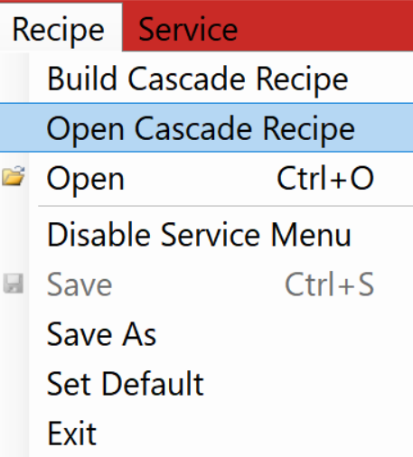

Figure : New Cascade Recipe Functions

## **Build Cascade Recipe**

## (Engineer Mode)

Building a Cascade Recipes can be performed by an Engineer using the new menu screen. To access the new menu, click the Recipetab and then the Build a Cascade Recipe. Navigating the new menu is intuitive, with only four buttons:

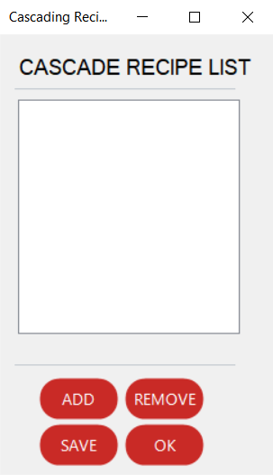

Figure : Cascade Recipe List buttons

1. ADD – add a recipe to the Cascade Recipe List.
2. REMOVE – Remove a recipe from the Cascade Recipe List.
3. SAVE – Save the current list as a Cascade Recipe.
4. OK – Confirm list and close the Cascade Recipe List.

## **Open Cascade Recipe**

Loading a Cascade Recipes can be performed by any user. To load a Cascade Recipe, click the Recipetab and then Open a Cascade Recipe. The Cascade Recipe will now automatically run all recipes in the list.

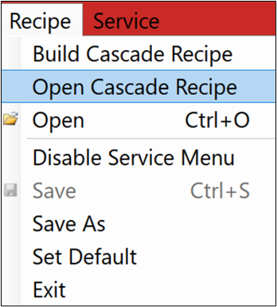

Figure : Open Cascade Recipe

## **1.2.6 Patch Notes**

* Added “Plasma Stable” label to the active plasma box
* Added “Error Active” label to the error code box

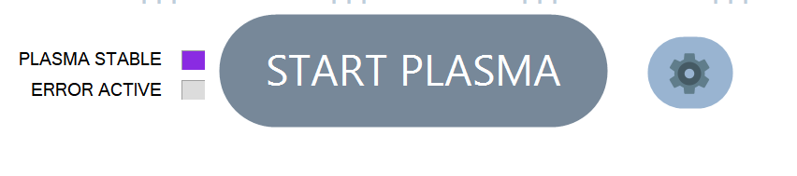

* Removed “dead” code - btn.clickExit functionality